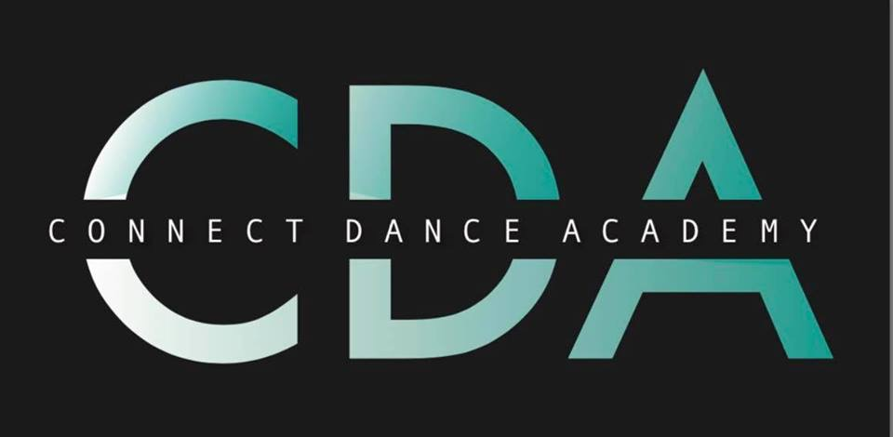
CODE OF CONDUCT FOR students

• Dancers must participate within the school rules and respect all the teachers/staff and their decisions.
• Dancers must respect their fellow school pupils/students.
• Dancers must arrive for training on time or inform the Dance Teacher if they are going to be late.
• Dancers must not distract, bully or harass other pupils/students during the class.
• Dancers must not use bad language.
• Dancers must be polite and display good manners at all times.
• Dancers must treat all equipment with respect.
• Dancers must wear the Connect Dance Academy uniform after 4 weeks of attending the school
• All body jewellery must be removed.
• Long hair must be tied back.
• Food, drink and chewing gum are strictly prohibited in the hall/gym (dancers may bring a sealed drinking bottle in the hall/gym but it must only contain water and must have the dancer’s name on).
• All litter must be placed in the bins provided.
• Please leave all valuables at home – Connect Dance Academy will not be held responsible for the loss of any items.
• Mobile phones and other electronic devices must be switched off in the hall/gym.
• Dancers must inform the Dance Teacher before the warm up begins if they have an injury or illness.
• Dancers must inform their teacher immediately if they begin to feel ill or sustain an injury during the class.
• Dancers must remain with teachers at the end of the class until they are safely collected by their parent or guardian.
• FINALLY ALL DANCERS MUST ENTER THE CLASS WITH A SMILE AND HAVE FUN!!

DISCIPLINARY PROCEDURE
• Dancers that breach the code of conduct will first of all be reminded of the rules.
• Repeatedly breaching the code of conduct may result in separation from other pupils/students (dancer will be made to sit out).
• Continuous breach of the code of conduct will result in the parents being informed at the end of the class by the Dance Teacher to discuss the situation. If there is no improvement, then parents will be contacted by the Dance Teacher and they will be invited to discuss the future behaviour of their child and agree joint strategies for monitoring. In extreme cases where physical violence, verbal abuse or intentional damage to property is involved, the sequence of actions outlined above will be by-passed and the Dance Teacher will contact the parents as a first step. Exclusion of the child from the school may be considered.

CODE OF CONDUCT FOR PARENTS / GUARDIANS

Connect Dance Academy is fully committed to safeguarding and promoting the well-being of all dancers, members and staff associated with the school. To ensure the effective running of our Dance Studio and to protect all individuals connected with the school it is important that the following codes of conduct are read, respected and adhered to at all times:

• All fees must be paid on time at the start of the week (if you pay weekly) & monthly payments up front otherwise your child may risk losing their place in the class. (New students will be allowed 4 weeks of cash payment and then you will receive an invoice)
• Encourage your child to learn the rules and perform within them.
• Arrive with plenty of time to get your child ready for their class and ensure they have been to the toilet before the session begins - Always inform the Dance Teacher if you are going to be late.
• Always ensure your child is dressed appropriately with long hair tied up and make sure they have had plenty to drink.
• No Parent/Guardian will be allowed in to the hall/studio during classes.
• Discourage challenging and inappropriate conduct towards teachers and other students.
• Help your child to recognise good performance and progression.
• Discourage comparison against other students - Each dancer is an individual with different goals and objectives and they must be praised on their own personal achievement.
• Set a good example within the dancer’s environment by recognising good sportsmanship and applauding good performances of all.
• Use correct and proper language at all times. Stop swearing on the grounds of Connect Dance Academy.
• Encourage and guide your child to accept responsibility for their own performance and behaviour.
• Keep the Dance Teacher informed if your child is ill or unable to attend classes.
• Endeavour to establish good communications with the school, teachers and staff for the benefit of all.
• Never challenge or threaten a teacher or member of the Connect Dance Academy team. Any concerns must follow the approved channels as outlined.
• Do not raise issues of disagreement publicly.
• Always collect your child promptly at the end of a class.
• Always support your child's involvement and help them to enjoy their sport.

Please understand that breach of this code of conduct may have repercussions and in extreme cases may result in your child/children losing their place at the school.

